PHYSICS

YEAR 12

Unit 3

2015

Name: _______________________________________________________

Teacher: ___________________________________________________

TIME ALLOWED FOR THIS PAPER

Reading time before commencing work: Ten minutes
Working time for the paper: Three hours

MATERIALS REQUIRED/RECOMMENDED FOR THIS PAPER

To be provided by the supervisor:
- This Question/Answer Booklet; ATAR Physics Formulae and Data Booklet

To be provided by the candidate:
- Standard items: pens, pencils, eraser or correction fluid, ruler, highlighter.

- Special items: Calculators satisfying the conditions set by the SCSA for this subject.

IMPORTANT NOTE TO CANDIDATES
No other items may be taken into the examination room. It is your responsibility to ensure that you do not have any unauthorised notes or other items of a non-personal nature in the examination room. If you have any unauthorised material with you, hand it to the supervisor before reading any further.

Structure of this paper

Section | Number of questions available | Number of questions to be answered | Suggested working time  (minutes) | Marks available | Percentage of exam
Section One:  Short answer | 10 | 10 | 50 | 54 | 30
Section Two:  Extended answer | 7 | 7 | 90 | 90 | 50
Section Three:  Comprehension  and data analysis | 2 | 2 | 40 | 36 | 20
 |  |  | Total | 180 | 100

Instructions to candidates

- The rules for the conduct of Western Australian external examinations are detailed in the Year 12 Information Handbook 2016. Sitting this examination implies that you agree to abide by these rules.

- Write answers in this Question/Answer Booklet.

- When calculating numerical answers, show your working or reasoning clearly. Give final answers to three significant figures and include appropriate units where applicable.

When estimating numerical answers, show your working or reasoning clearly. Give final answers to a maximum of two significant figures and include appropriate units where applicable.

- You must be careful to confine your responses to the specific questions asked and follow any instructions that are specific to a particular question.

- Spare pages are included at the end of this booklet. They can be used for planning your responses and/or as additional space if required to continue an answer.
  - Planning: If you use the spare pages for planning, indicate this clearly.
  - Continuing an answer: If you need to use the space to continue an answer, indicate in the original answer space where the answer is continued, i.e. give the page number. Refer to the question(s) where you are continuing your work.

Section One: Short response 30% (54 Marks)

This section has 10 questions. Answer all questions. Write your answers in the space provided. Suggested working time for this section is 50 minutes.

Question 1 4 marks
Kepler’s 3rd law of planetary motion is:
$$T^{2}= \frac{{4π}^{2}}{GM} r^{3}$$
Derive this formula using at least two other equations from the supplied data sheet. Show ALL steps in your working.
$F_{g}= \frac{{Gm}_{1}m_{2}}{r^{2}}$ $F_{C}= \frac{m_{2}v^{2}}{r}$ 1 mk
$F_{g}= F_{C}$ 1 mk
$\frac{{Gm}_{1}m_{2}}{r^{2}}$ = $\frac{m_{2}v^{2}}{r}$ (change m₁ to M) $v= \frac{2πr}{T}$ 1 mk
$\frac{GM}{r}= \frac{4π^{2}r^{2}}{T^{2}}$ rearrange gives 1 mk
$$T^{2}= \frac{{4π}^{2}}{GM} r^{3}$$

Question 2 6 marks
A spherical, 2.00 kg ball, rests on a plane with a slope of 30.0⁰ as shown in the diagram below. 3 marks

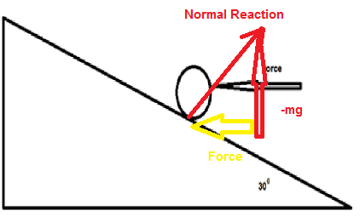
  - Calculate the minimum horizontal force that will prevent the ball moving down the frictionless plane.
1 mk for diagram
tan 30⁰ = $\frac{Force}{mg}$ = $\frac{Force}{2 x 9.8}$ 1 mk
Force = 11.3 N 1 mk

  - The horizontal force is removed. Calculate the normal reaction force provided by the plane on the ball. 3 marks
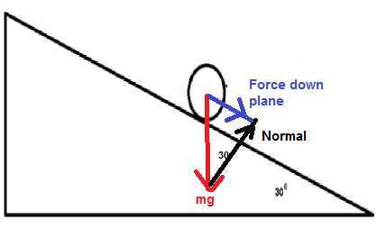1 mk
Normal = cos 30⁰ x mg = 0.8660 x 2 x 9.8 = 17.0 N
1mk 1 mk

Question 3 8 marks
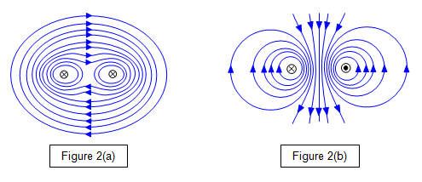
The two parallel wires shown below each has an 8.00 A current flowing; one is into the page while the other is out of the page. The wires are 5.30 cm apart.

  - Draw the magnetic field in the space surrounding the two wires. (3 marks)
1 mark each for correct circular direction of field surrounding wires.
1 mark for the interaction of the two fields between the wires. (no lines crossing, denser field between wires)

  - Calculate the magnitude of the magnetic flux density at a point 1.50 cm from the left wire, towards the right wire. (5 marks)
Find field due to left wire.
$B=\frac{μ_{0}}{2π}*\frac{I}{r}=\frac{1.26*10^{-6}}{2π}*\frac{8.00}{0.015}=1.069*10^{-4} T$
2 marks (distance and formula)

Find field due to right wire.
$B=\frac{μ_{0}}{2π}*\frac{I}{r}=\frac{1.26*10^{-6}}{2π}*\frac{8.00}{0.053-0.015}=4.222*{10}^{-5} T$
2 marks (distance and formula)

Combine the fields
$B=B_{left}+B_{right}=1.49*{10}^{-4} T$ 1 mark

Question 4 7 marks
The volume of a hydrogen atom is 1.99 x 10⁻³¹ m³. Assume the atom is a sphere and the electron travels along its surface.
Calculate the force between the proton and the electron:
    - Gravitational 4 marks
$v= \frac{4}{3}{πr}^{3}$ 1.99 x 10⁻³¹ = $\frac{4}{3}{πr}^{3}$ r = 3.62 x 10⁻¹¹ m
1 mk 1 mk
F = $\frac{G m_{1}m_{2}}{r^{2}}$ = $\frac{{6.67 x 10}^{-11}{1.67 x 10}^{-27}{9.11 x 10}^{-31}}{{{(3.62x 10}^{-11})}^{2}}$ = 7.74 x 10⁻⁴⁷ N
1 mk 1 mk

    - Electromagnetic 2 marks
$F= \frac{1}{{4πε}_{0}}\frac{q_{1}q_{2}}{r^{2}}$ = $\frac{1}{{4π 8.85 x 10}^{-12}}\frac{(1.6 {x 10}^{-19}){}^{2}}{{{3.62 x 10}^{-11}}^{2}}$ = 1.76 x 10⁻⁷ N
1 mk 1 mk

    - Total 1 mark
1.76 x 10⁻⁷ N (mark is for adding (a) and (b))

Question 5 4 marks
Juliette (43.2 kg) decided to build a seesaw using a 4.12 m uniform beam The fulcrum was placed midway along the beam. She was accompanied by her friend, Ben (55.7 kg) and her sister, Claire (21.6 kg). Ben sits at the maximum distance from the fulcrum. Draw a diagram with the relevant distances and forces shown to help describe where Juliette and Claire could sit so that the seesaw is in equilibrium. Note that Juliette and Claire must sit at different distances from the fulcrum.

Claire 212 N
Juliette 423 N
Ben 546 N

1 mk for diagram showing Ben on one side and girls on the other.

$\sum{τ_{cw}}=\sum{τ_{acw}}$
$τ_{ben}=τ_{claire}+τ_{Juliette}$ 1 mk
$546*\frac{4.12}{2}=212*r_{c}+423*r_{J}$ 1 mk
$r_{c}+1.995r_{J}=5.305$ 1 mk
Choose a suitable value for r_{c} and r_{J} (neither can be larger than 2.06 m) 1 mk

Question 6 6 marks

  - On the following diagram draw the magnetic fields. Draw at least ten lines.
4 marks
1 mk show lines for repulsion (Nearby North ends)
1 mk lines attraction (Lines move between North and South ends)
1 mk lines directed towards iron ball
1 mk lines direction correct

-1 mk lines touch
-1 mk lines don’t start on magnets/ball

  - Draw the electric fields of the following diagram. Draw at least five lines.
2 marks
1 mk direction
1 mk shape
Question 7 (6 marks)
A roller coaster with three passengers has a mass of 9.73 x 10² kg. The participants experience being upside down at the top of the circular track of a “loop the loop” showground ride. The centre of mass of the roller coaster and passengers is 15.3 m from the bottom of the ride. It is travelling at a constant speed of 12.3 m s^{–1}.
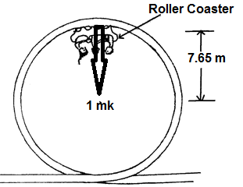
  - On the diagram draw a vector to indicate the direction of the force of the rail acting on the coaster plus passengers. (1 mark)

  - Calculate the magnitude of the force that the rails at the top of the ride exerts on the coaster plus passengers. (5 marks)

Centripetal Force = $\frac{{mv}^{2}}{r}$
F = $\frac{{9.73 x 10}^{2}{12.3}^{2}}{7.65}$ N 1 mark
F = 1.92 x 10⁴ N 1 mark

Weight = mg
Wt = 9.73 x 10² x 9.80 N
Wt = 9.54 x 10³ N 1 mark
Force of rails on coaster + passengers = Centripetal force – weight 1 mark
Force of rails on coaster + passengers = 1.92 x 10⁴ – 9.54 x 10³ N
= 9.71 x 10³ N 1 mark
Question 8 4 marks
An electric beater is used to make bread dough of the right consistency. During normal operation the beater spins at a high rpm to mix the dough. When the bread dough was too thick, the electric motor jammed and consequently melted. Explain why this happened when the beater was stuck but does not occur when the beater is spinning.
The electric motor in the beater also acts as a generator thus creating a back emf (1 mk)
This back emf reduces emf across the coil in the motor (1 mk).
This means smaller current through the coil (1 mk).
Motor stops spinning back emf stops, emf across coil is much greater, greater current (1 mk) coil overheats.

Question 9 3 marks
The most common form of regenerative braking in a car involves using the car’s electric motor as a source of emf. Explain how this occurs and why this process also helps to slow the car down.
When the driver brakes, the motor changes into a generator (moving coil in magnetic field produces electricity). (1 mk)

This electric current recharges the batteries. (1 mk)

Conservation of energy informs that this electrical energy is converted from the source energy (E_{K}), which slows the car.
OR
The rotating coil feels a resistive force due to Lenz’s law which slows the car. (1 mk)

Question 10 6 marks
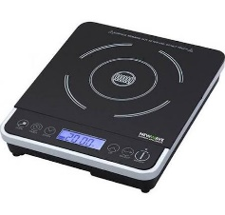
The diagram shows a typical hotplate which is common used in households. It can heat water in a saucepan without using flame.

- Explain how these hotplates can heat water in a saucepan. Include in your answer what material should the saucepan to be made for it to works best. 4 marks
An induction heater consists of an electromagnet driven by a high frequency AC. (1 mk)
This creates eddy currents in the metal of the saucepan. (1 mk)
These currents, due to resistance, create heat. (1 mk)
Steel or iron (1 mk)
Magnetic hysteresis losses in ferromagnetic materials adds to heating

- Does the hotplate get hot while the device is on without a saucepan on top? Explain. 2 marks
As there is no metal conductor where an induced emf can be produced, there is no resistive heating and so the hotplate does not get hot. 2 marks.

Section Two: Problem-solving 50% (90 Marks)

This section has seven (7) questions. You must answer all questions. Write your answers in the space provided. Suggested working time for this section is 90 minutes.

Question 11 12 marks
Two 20.0 kg six-year-old children sit next to each other with their shoulders touching.
  - Estimate the gravitational force between them. 3 marks
Assumptions: $F= \frac{GMm}{r^{2}}$ F = $\frac{{6.67 x 10}^{-11}{*20}^{2}}{{0.5}^{2}}$ 1 mk
r = 0.5 m F = 1.1 x 10⁻⁷ N 1 mk for 2 sig figs
1 mk for reasonable estimates

  - Draw the gravitational field of one of the children (Use at least 6 field lines.)
3 marks
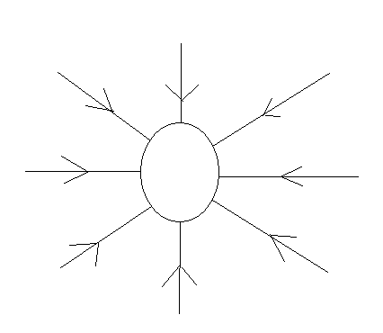
1 mk 6 or more lines start at surface
1 mk lines direction towards child’s centre of mass
1 mk no lines touch

  - One of these two children is lying on the floor. He climbs on top of a shelf and stands upright. The shelf is one metre above the ground. Estimate the work done by the child to reach this position. (Hint: consider where the child's centre of mass is located).
(3 marks)
3 marks
Assumptions:
W= ΔE 1 mk
E_{P} = mgh
Centre of Mass = 0.6 m above Ep = 20 x 9.8 x 1.6 1 mk
feet when standing E_{P} = 3.1 x 10² J
1 mk for reasonable estimate

  - One of the children in Question 2 steps of the shelf. When their centre of mass is 0.700 m above the ground estimate their velocity and kinetic energy.
3 marks
E_{P} = mgh = 20 x 9.8 x 0.7 = 1.4 x 10² J 1 mk
E_{K} = $∆E_{p}=\left(3.1-1.4\right)$x 10² J = 1.7 x 10² J 1 mk (apply follow through from part c).
$v= \sqrt{\frac{{2E}_{K}}{m}}$
$v= \sqrt{\frac{{2 x 1.7{x10}^{2}}_{}}{20}}$ 1 mk
v = 4.1 m s⁻¹

Question 12 17 marks
The Perth Wildcats basketball team is two points down and Nat Jawai has the ball in centre court. He puts up the shot and scores.

- In the space below, draw a diagram of the ball showing the force/s acting on it whilst in flight. Assume no air resistance and do not add any extra arrows.
(2 marks)
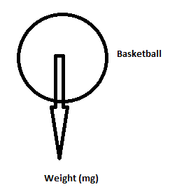
2 mks for just 1 force, 1 off for each additional arrow added

- He propels the ball at an angle to the horizontal of 42.5⁰. What is the initial speed of the ball? 6 marks
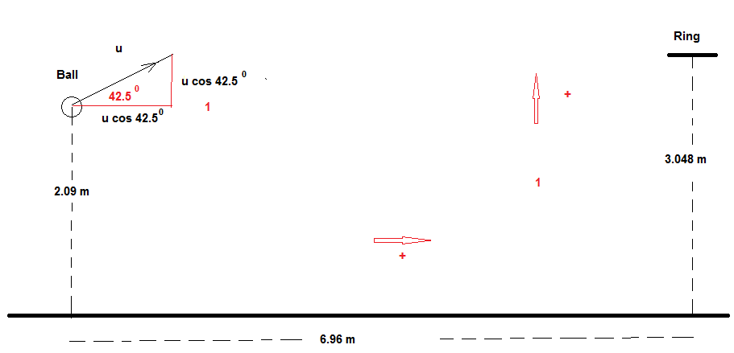
Horizontal Vertical
s_{h} = 6.96 m s_{v} = (3.048 – 2.09) m = 0.958 m
u_{h} = u cos 42.5⁰ m s⁻¹ u_{v} = u sin 42.5⁰ m s⁻¹
a_{h} = 0 a_{v} = -9.80 m s⁻²
t_{h} = T s t_{v} = T s
3 mks for indicating how to find uh, uv, sv anywhere in solutions

$t_{h}= \frac{s_{h}}{u cos A }= \frac{6.96}{u cos 42.5 }$ (1 mk)
$s_{v}=ut+ \frac{1}{2} at^{2}$ (substitute in equation for time)
0.958 = u sin A x $\frac{6.96}{u cos A }$ + $\frac{1}{2} \left(-9.80\right) x (\frac{6.96}{u cos A })$²
0.958 = tan 42.5 x 6.96 + $\frac{1}{2} \left(-9.80\right) x (\frac{6.96}{u cos 42.5 })$² (1 mk for this step, even if not simplified)
0.958 = 6.38 - $\frac{437}{u^{2}}$
u² = 437/(6.38-0.958) = 80.6
u = 8.98 m s⁻¹ (1 mk)

- Calculate the velocity as it passes through the ring in order to score the three points to win the game. If you could not find an answer to part a) you may consider the initial speed of the ball to be 6.50 ms⁻¹. (7 marks)
u_{h} = u cos 42.5 = 6.61 m s⁻¹ = v_{h} (1 mk) u_{v} = u sin 42.5 = 6.06 m s⁻¹ (1 mk finding u_{v})
v² = u² + 2as
v² = 6.06² + 2 (-9.8) 0.958
v²= 18.0 v = $±$4.24 m s⁻¹ (1 mk)
Use -4.24 m s⁻¹ as is going down (1 mk)
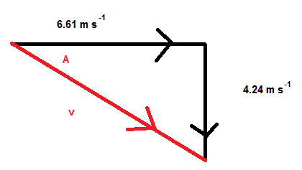1 mk for diagram (not necessary but is evidence for part marks)
v² = 6.61² + 4.24² tan A = $\frac{4.24}{6.61}$
v = 7.86 m s⁻¹ (1 mk) A = 32.7⁰ below horizontal (1 mk)

- On the diagram below draw the path of the ball with and without air resistance. Assume that the basketball is launched with the same initial velocity. (2 marks)
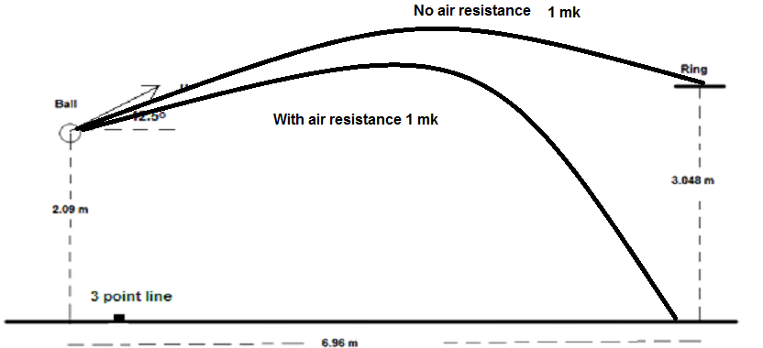
No air resistance path must pass through the ring while with air resistance falls short.

Question 13 11 marks
At the centre of the Milky Way is a black hole known as Sagittarius A*. It has a mass equivalent to 4.31 billion Suns. It is 26 500 light years from the Sun.
- Calculate the gravitational force between the black hole and the Sun.
3 marks
$$F= \frac{{Gm}_{1}m_{2}}{r^{2}}$$
$F= \frac{{{6.67* 10}^{-11}{1.99* 10}^{30}{*4.31* 10}^{9}{*1.99* 10}^{30}}_{}}{{{(26500 x 365 x 24 x 3600 x {3 x 10}^{8})}^{2}}^{}}$
1 mark for mass of black hole.
1 mark for calculation of distance using s=vt

F = 1.81 x 10¹⁹ N (1 mk) 1 mark for distance

- Use this force (from part a), to calculate the orbital speed of the Sun as it follows an approximately circular orbit around the black hole. If you cannot determine a value to part (a) you may use 2.00×10¹⁹ N. (3 marks)

$$F= \frac{m_{2}v^{2}}{r}$$
1.81 x 10¹⁹ = $\frac{{1.99 x 10}^{30}v^{2}}{{26500 x 365 x 24 x 3600 x 3 x 10}^{8}}$ (2 mks)
v = 4.78 x 10⁴ m s⁻¹ (1 mk)
(answer is 5.02×10⁴ ms⁻¹ if used force supplied in question)

- The Sun moves around the black hole (assume circular orbit) with a speed of 2.20 x 10² km s⁻¹. Calculate the centripetal force involved in creating this orbit.
2 marks
2.20 x 10 2 km s⁻¹ is 2.20 x 10⁵ m s⁻¹ 1 mark
$F= \frac{m_{2}v^{2}}{r}$
$F= \frac{{1.99 x 10}^{30}{{2.20 x 10}^{5}}^{2}}{{26500 x 365.25 x 24 x 3600 x 3 x 10}^{8}}$ (1 mk)
F = 3.84 x 10²⁰ N

- C Compare the values of the forces found in part a) and c). Suggest a physical reason for the comparison (not simply because the actual speed of the Sun is different to that calculated in part b).
(3 marks)

The second force is ~20x greater than the first, possibly because: (1 mk)
- Mass from rest of Milky Way contributes to force
- Dark matter
- Error in estimates (mass of Sagittarius A*)
- Error in estimates (distance between objects)
(2 mks for any two or other possibilities)

Question 14 15 marks
A yacht is moored in a marina being prepared for the Sydney to Hobart race. The uniform boom is 1.50 m above the deck and the negligible mass cable is attached 1.20 m from the end of the boom (boom has a 61.5 kg mass). A 50.0 kg weight is attached at the free end of the boom to prevent sudden movement.

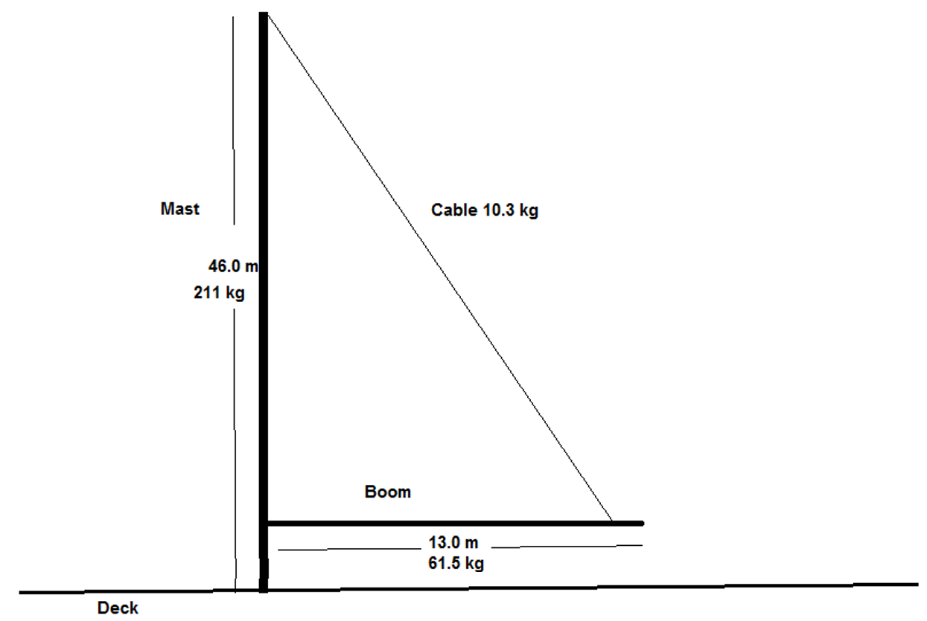
  - Draw a free body diagram of the boom showing all forces acting on it.
4 marks
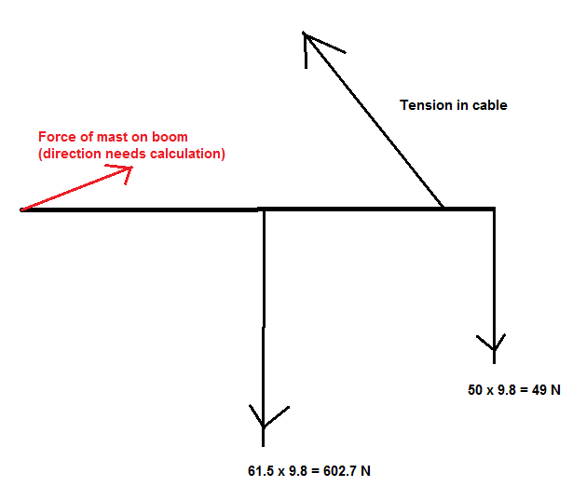
1 mk for each force correct with approximate direction. -2 if drawn the addition of the forces and not a free body diagram. No particular direction of reaction force is required.
  - Calculate the tension in the cable. 5 marks
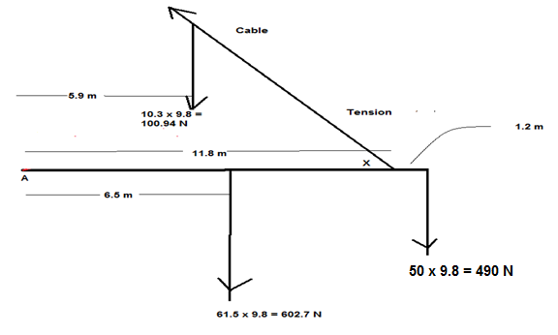
Calculate X: tan X = $\frac{44.5}{11.8}$ X = 75.1⁰ 1 mk

Take moments about A
Tension torque = 50 kg weight torque + boom weight torque 1 mk
T x 11.8 sin 75.1⁰ = 490 x 13 + 602.7 x 6.5
1 mark for each force with appropriate distance (3 marks total)
T = 902 N

  - Calculate the reaction force exerted by the mast on the boom. 5 marks
Vertical Forces (down +)
F_{V} = 602.7 + 490 – 902 sin 75.1⁰ = 221 N (1 mk)
Horizontal Forces (left +)
F_{H} = 902 cos 75.1⁰ = 232 N (1 mk)
F
F_{v}
ϴ
F_{H}
1 mk diagram (not required but evidence for part marks)
Force of mast on boom = (232² + 221²)^{0.5} = 320 N (1 mk)
ϴ = tan⁻¹ $\frac{221}{232}$ = 43.6⁰ above the boom OR 46.4⁰ from vertical (1 mk)

  - Describe how the tension in the cable changes when it is attached to the boom at a position closer to the mast. (1 mark)
Shorter length produces a smaller tension in the cable.

Question 15 17 marks
AC and DC generators are important technological devices.
- Using a labelled diagram illustrate how an AC generator creates an AC voltage. Be sure to include an external load, fixed external magnets and any equipment needed to output an AC voltage. A simple 2D diagram is acceptable. Describe how the AC voltage is produced using this equipment. (6 marks)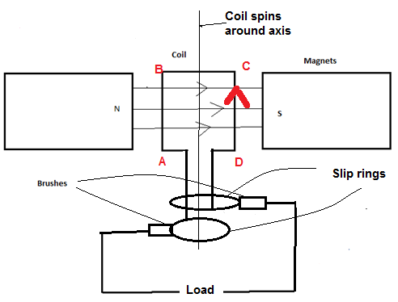
3 mks (-1 mk for each missing/unlabelled component)
Coil is spun in magnetic field, produces emf 1 mk
Every half turn the change in flux is reversed through the coil, reversing the emf 1 mk
Slip rings allow emf in coil to apply to external circuit, which gives AC voltage 1 mk

- At which stage of the cycle is maximum emf generated. Explain. 3 marks
When coil is parallel with field OR when no flux is contained in area of coil. 1 mk
Size of emf is determined rate of change of flux. The greatest change in flux occurs as the coil rotates past a point that makes its area parallel with the field. 2mk

- Explain the difference in design necessary to change the AC generator to a DC generator. Use diagrams. 5 marks
Change the slip rings (AC) to split ring commutators (DC) 1 mk
The slip rings never change which side of the coil they are connected to so the naturally produce AC flows through to the external load. (2 mks)
The split ring commutator takes the AC output of the generator and flips the direction of the current passing through to the load every half a turn. This turns an AC supply into a DC supply (2 mks)

- The equation
$${emf}_{rms}= \frac{{emf}_{max}}{\sqrt{2}}$$
is used to calculate the maximum emf created in an AC generator. Explain, using appropriate diagrams: what is the importance of $\sqrt{2 }$in this equation.
3 marks
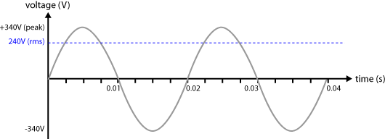\
If rms line is DC and more than half of the peak value (2 mks)
If rms line is DC but appears equal to or less than half of the peak value (1 mk only )
It is the "effective" voltage of an AC emf, allowing it to be compared to a DC emf source.
1 mk

Question 16 13 marks
Two parallel charged plates are set up as in the diagram below.
- Draw the electric field between the plates 3 marks
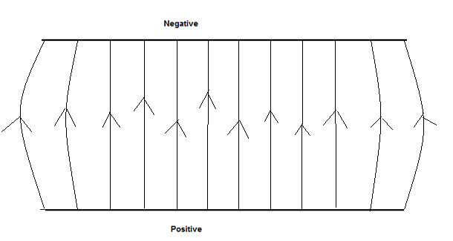
1 mk for field up
1 mk for equal distance between lines
1 mk for bowed ends

- A proton is fired, with a velocity of 8.67 x 10⁷ m s⁻¹, into the space between the 0.500 m long plates as shown below. The plates are 20.0 mm apart and the potential difference between the plates is 3.00 x 10³ V.
The experiment is placed vertically to the ground and the proton is affected by gravity.
Calculate the total force acting on the proton as it travels between the plates.
(3 marks)
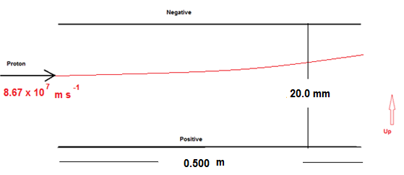 Gravitational = mg = 1.67 x 10⁻²⁷ x 9.80 N = 1.64 x10⁻²⁶ N down 1 mk
Electric Field force = $\frac{Vq}{d}$ = $\frac{3000 x {1.6 x 10}^{-19}}{0.020}$ = 2.4 x 10⁻¹⁴ N up 1 mk
Total force up = 2.40 x 10⁻¹⁴ N up 1 mk

- Calculate the speed with which the proton leaves the gap between the pates. 5 marks
vertical acceleration: a = $\frac{F}{m}$ = $\frac{{2.4 x 10}^{-14}}{{1.67 x 10}^{-27}}$ = 1.44 x 10¹³ m s⁻² 1 mk
Vertical
t = $\frac{s}{v}= \frac{.5}{{8.67 x 10}^{7}}$ = 5.77 x 10⁻⁹ s 1 mk

v = u + at = 0 + 1.44 x 10¹³ x 5.77 x 10⁻⁹ = 8.31 x 10⁴ m s⁻¹ 1 mk
Horizontal
v = 8.67 x 10⁷ m s⁻¹ 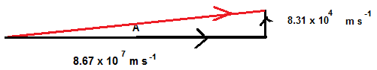
1 mk for diagram (not necessary but is evidence for part marks)
Final velocity = [(8.67 x10⁷)² +(8.31 x10⁴)²]^{0.5} = 8.67 x 10⁷ m s⁻¹ 1 mk

- Calculate the vertical displacement of the proton whilst it is between the plates.
2 marks
$t=$5.77 x 10⁻⁹ s
$s_{v}=u_{v}t+\frac{1}{2}a_{v}t^{2}$ ($u_{v}$ is zero) 1 mk
$s_{v}=\frac{1}{2}*1.44*{10}^{13}*{\left(5.77*{10}^{-9}\right)}^{2}=2.40*{10}^{-4} m up$ 1 mk

Question 17 (5 marks)
A truck is being driven around a roundabout, of radius 75.0 m, and it rolls over.
- Explain, referring to centre of mass and a suitable diagram, at which critical point the truck would roll over rather than remain upright. (2 marks)
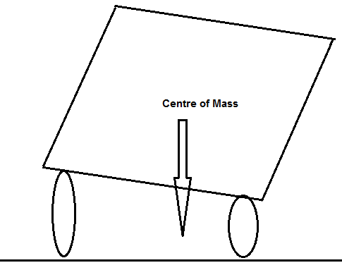 1 mk
If truck leans over so that the vertical line from CoM to the ground is outside of wheelbase it will roll over 1 mk

- Road engineers bank roads to help prevent such situations occurring. What angle must the road in part a) be banked to allow the driver to travel through the roundabout, safely, at 18.0 m s⁻¹. At the safe speed the truck corners without relying on friction between the wheels and the road. (3 marks)

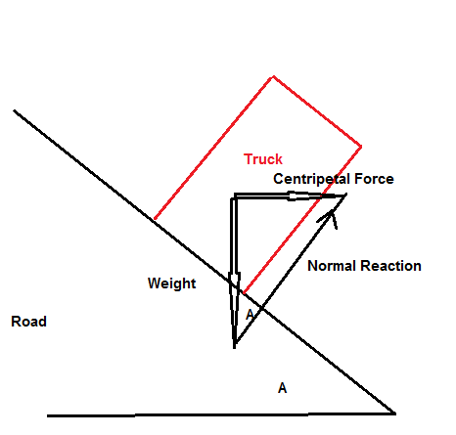 1 mk
tan A = $\frac{Centripetal Force}{Weight}= \frac{{mv}^{2}}{mgr}= \frac{v^{2}}{gr}= \frac{{18}^{2}}{9.8 x 75}$ 1 mk
A = 23.8º 1 mk

Section Three: Comprehension 20% (36 Marks)

This section contains two (2) questions. You must answer both questions. Write your answers in the space provided. Suggested working time for this section is 40 minutes.

Question 18 Circular Motion (18 marks)
Many everyday examples rely on circular motion. Satellites for weather observations, GPS, communications and monitoring activities is one such group. Some others include spin dryers in washing machines, separating blood samples into its components in a centrifuge and mass spectrometers.

Centrifugal force does not exist in an inertial frame of reference and is generally considered to be a “mythical” or inertial force. In the past it was sometimes defined as the reaction force to the centripetal force. Centrifugal is based on the Latin word which means flight (moving away from centre), centripetal comes from the Latin for seeking (moving towards centre).
A satellite orbiting the Earth in a circular orbit is always falling towards the Earth yet maintains the same altitude.
Rockets are used to place satellites in their respective orbits. Satellites that have orbits parallel to Earth’s equator are generally launched in an easterly direction from the east coast close to the equator.
Geostationary satellites are usually launched in this manner. These satellites are a significant reason that we can receive continuous TV signals from the other side of the world. Pay TV companies also use geosynchronous satellites as well as cable to provide services to their customers. They are also valuable in weather services as each satellite monitors a set part of the Earth’s surface.

An experiment to demonstrate the forces involved in circular motion is set up as follows:
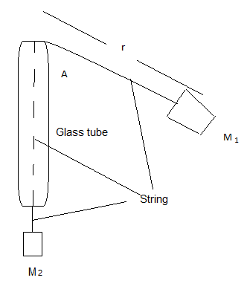
A student holds the glass tube and swings the rubber stopper (M₁) in a circle maintaining a constant radius. The force (tension in the string) is provided by the mass (M₂). Another student measures the time taken for 25 revolutions.
The following is a set of results for one such experiment.

M₁ completes at least 25 circuits.
M₁ has a mass of 38.3 g
R is 61.3 cm
Force of M₂  (N) | Time for twenty (25) revolutions  (s) | Period  (s) | Velocity²  (m² s⁻²)
0.50 | 34.1 | 1.36 | 8.0
1.50 | 19.7 | 0.79 | 23
2.50 | 15.3 | 0.61 | 40
3.50 | 12.9 | 0.52 | 56
4.50 | 11.4 | 0.46 | 71
5.50 | 10.3 | 0.41 | 87

- Complete the two incomplete columns. 2 marks
(-1/2 mark per mistake)
- Which is the independent variable? 1 mark
Force / mass of M2

- Plot the data. 4 marks
TITLE: Force and velocity² graph
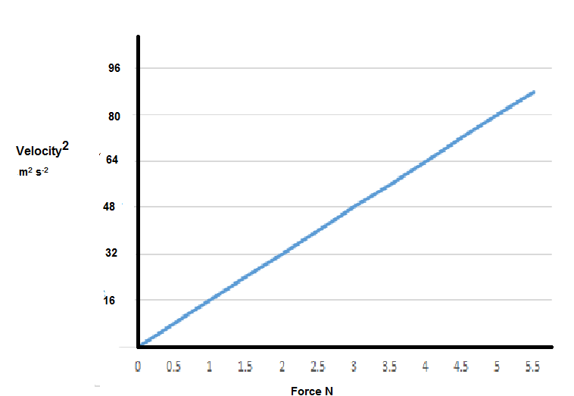

1 mk accuracy of points, 1 mk suitable line of best fit, 1 mk labels, 1 mark units

- Find the gradient of the graph (2 marks)
Gradient = $\frac{Rise}{Run}$ = $87/5.5$ = 15.8 N s² m⁻² 1 mk magnitude, 1 mk units
OR = [15.8 kg m⁻¹]
- What is the important information of the gradient? (1 mark)
The length of the string (r) divide the mass of M1 (swinging mass)
If vague (e.g.: length divide mass) only ½ a mark)
- No matter how fast you can reasonably make M₁ travel it will never make the string perfectly horizontal. Explain. 1 mark
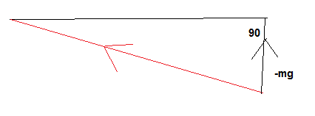
Tension in the string must have component to support weight 1 mk
- A satellite that is constantly falling can maintain a circular path around the Earth at a constant altitude. Explain why a satellite is constantly falling and why the altitude can remain constant. 3 marks

Centripetal force (gravity) pulls the satellite towards the Earth. 1 mk
The distance the satellite falls towards the Earth is equal the distance the Earth's surface curves away from the satellite, thus it maintains a constant altitude. 2 mks

- Explain why, that when a satellite is in a circular orbit around the Earth the centre of its orbit must be the centre of mass of the Earth. Use diagrams. 3 marks
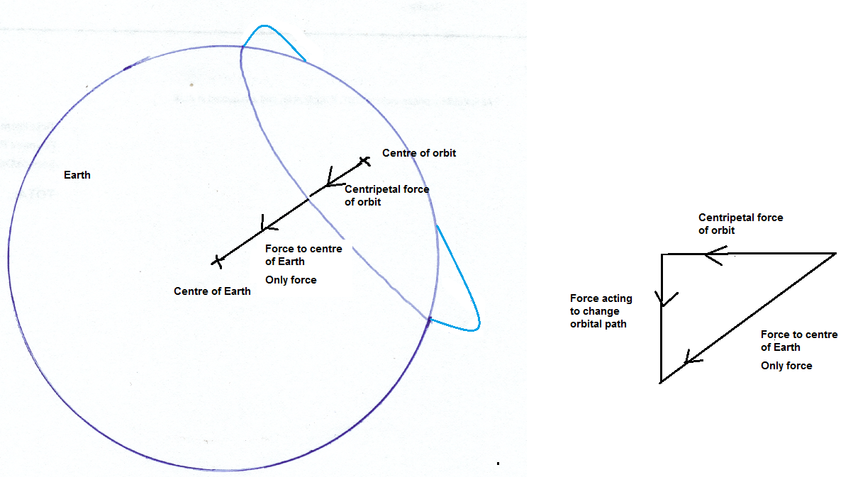

To maintain a circular orbit, the sum of the physical forces must produce the centripetal force. Gravitational forces push a satellite towards the centre of mass of the Earth, thus this must also be the centre of the orbit.
2 mk explanation
1 mk diagram (other diagrams that suitably show force and centre of mass of Earth are possible)

- Whilst falling the satellite could be said to be weightless. Explain. 1 mark
Perception of weight is due to the reaction force of the ground. In free fall no reaction force. (1 mk).

Question 19 AC/DC: Rock Band or Electricity Wars (18 marks)
Edison and Tesla, two great scientists found themselves on the opposite sides of the debate whether to use DC (Edison) or AC (Tesla).
Edison to prove his point that AC was too dangerous electrocuted an elephant and advocated that AC be used for the electric chair. Further he built 121 DC power stations in the United States of America. The Boulder power station in the Goldfields of Western Australia was originally a DC power station. Unfortunately, users of this power had to be within 2 km of the station.
AC power could be readily converted from low to high voltages and back again so it could be transferred long distances with lower energy losses.
Much of our electronics today use DC power and when the AC is converted to DC about 3% energy is lost in the form of heat. Also LEDs are designed to use DC and so suffer from flicker on an AC supply which reduces their lives. Solar panels produce DC current which is converted to AC using inverters. DC can now be converted to high voltages relatively easily and voltages for transmission of up to 800 kV have been achieved.
An issue with high voltage AC is the “skin effect” which means that at high voltages the current travels on the outside of the wire which effectively increases the resistance of the wire. This then requires that more expensive multi-strand wires are required to transmit the power. DC systems do not have this issue.
Further many places use UPSs (Uninterruptable Power Supplies) which convert AC to DC (batteries) then back to AC and then back to DC to run the electronics.
Should we convert our power supplies to DC which is safer, much of our electronics use DC already and much of the green energy produced is DC and would be more compatible with a DC grid.
On the reverse many of our appliances are AC based and our power stations are all built to provide AC. Converting them would be a huge expense.
The South/West power grid operated by Western Power extends from Kalbarri (600 km North of Perth) to Ravensthorpe (530 km SE of Perth) across to the coast, with an extension to Kalgoorlie.
Synergy is the electricity generator and retailer for the grid. They charge domestic customers 23.36630 cents per unit. A unit is one kilowatt-hour which is found by multiplying the power consumed in kilowatts by the number of hours the power is used for.
A typical power station can generate 6.00 x 10² MW of energy at 30.0 kV. This is then sent to a sub-station where the voltage is stepped up to 3.30 x 10² kV. This is then transported at that voltage over large distances through a transmission line. It then comes to a series of sub-stations that step down the voltage to 33.0 kV, then 11.0 kV, 6.00 kV and finally about 4.00 x 10² V in Western Australia. Each transformer stage loses approximately 1.00% (ie 99% efficient) and power is also lost through the transmission line.
The three phase power is distributed from the last sub-station as three phase power down the streets. Most houses opt for being supplied with one phase power (~2.40 x 10² V) at a frequency of 50.0 Hz.
Large voltage wires are usually multi-strand aluminium cables surrounding an iron core which provides the tensile strength. The resistance of the wire is 1.02 x 10⁻⁴ Ω m⁻¹.

- Explain why multi-strand wires are used in large voltage power lines.
2 marks
High voltage electricity travels on outside of wire increasing resistance 1 mk
Multi-strands provide more skin volume to carry current 1 mk

- Calculate the energy lost in transmitting 600 MW AC electricity from the power station to the first step down sub-station in a town which is 151 km away. Do not include the power lost at the first step down sub-station. 7 marks
Power loss in step up transformer 1.00% is 1/100 x 600 MW = 6.00 MW 1 mk
P = VI (Use the power on the secondary side and the stepped up voltage)
5.94 X 10⁸ = 330 x 10³ x I 1 mk
I = 1.80 x 10³ A (current transmitted through line) 1 mk
P_{loss} = I²R = (1.80 x 10³)² x (151 x 10³ x 1.02 x 10⁻⁴)
1 mk 1 mk
P_{loss in wires} = 5.59 MW 1 mk
Total Power loss = 41.2+6.00=47.2 MW 1 mk

- Calculate the loss over a year in possible revenue that Synergy loses because of this loss of energy. 4 marks
1 year = 365.25 x 24 = 8.77 x 10³ hours (hr) 1 mk
Energy loss = t x P = 8.77 x 10³ hr x 47.2 x 10³ kW = 4.14 x 10⁸ kW hr 2 mks
Cost = $4.14 x 10⁸ x 0.2336630 = $96.8 million 1 mk

- What is the largest transmission voltage used in Western Australia? 1 mark
330 kV or 3.30×10² kV
- Explain the cause of the “flicker” in LEDs. 3 marks
LEDs need to run on DC 1 mk
Since the supply oscillates 50 times every second there are times no current flows 1 mk
So the light turns on and off. 1 mk

- Why does DC lose less power in transmission than AC? 1 mark
Resistance in wires is less (no skin effect like in AC)

